**DAILY ONLINE ACTIVITIES SUMMARY**

|  |  |  |  |  |  |  |  |
| --- | --- | --- | --- | --- | --- | --- | --- |
| **Date:** | **10 June 2020** | | | **Name:** | | **KHATHEEJA SAFREENA.** | |
| **Sem & Sec** | **4th sem, 2nd year** | | | **USN:** | | **4AL18CS037** | |
| **Online Test Summary** | | | | | | | |
| **Subject** | | **OBJECT ORIENTED CONCEPTS (18cs45)** | | | | | |
| **Max. Marks** | | **30** | | | **Score** | **14** | |
| **Certification Course Summary** | | | | | | | |
| **Course** | **CLOUD FOUNDATIONS.** | | | | | | |
| **CertificateProvider** | | | **Great learning** | | **Duration** | | **6 hours** |
| **Coding Challenges** | | | | | | | |
| **Problem Statement:2 program** | | | | | | | |
| **Status: Executed** | | | | | | | |
| **Uploaded the report in Github** | | | | | **Yes** | | |
| **If yes Repository name** | | | | | **[http://shafreenasharief / lockdown-coding](http://shafreenasharief / lockdown-coding" \o "http://shafreenasharief / lockdown-coding)**  **[http://shafreenasharief / locked-down--certification-course](http://shafreenasharief / locked-down--certification-course" \o "http://shafreenasharief / locked-down--certification-course)**  **[http://shafreenasharief / Daily\_Report](http://shafreenasharief / Daily_Report" \o "http://shafreenasharief / Daily_Report)** | | |
| **Uploaded the report in slack** | | | | | **Yes** | | |

Online Test Details: (Attach the snapshot and briefly write the report for the same)

Certification Course Details: (Attach the snapshot and briefly write the report for the same)

Coding Challenges Details: (Attach the snapshot and briefly write the report for the same)

**ONLINE TEST SUMMARY**

**Today OBJECT-ORIENTED CONCEPTS (18cs45) was conducted for 30 marks.**

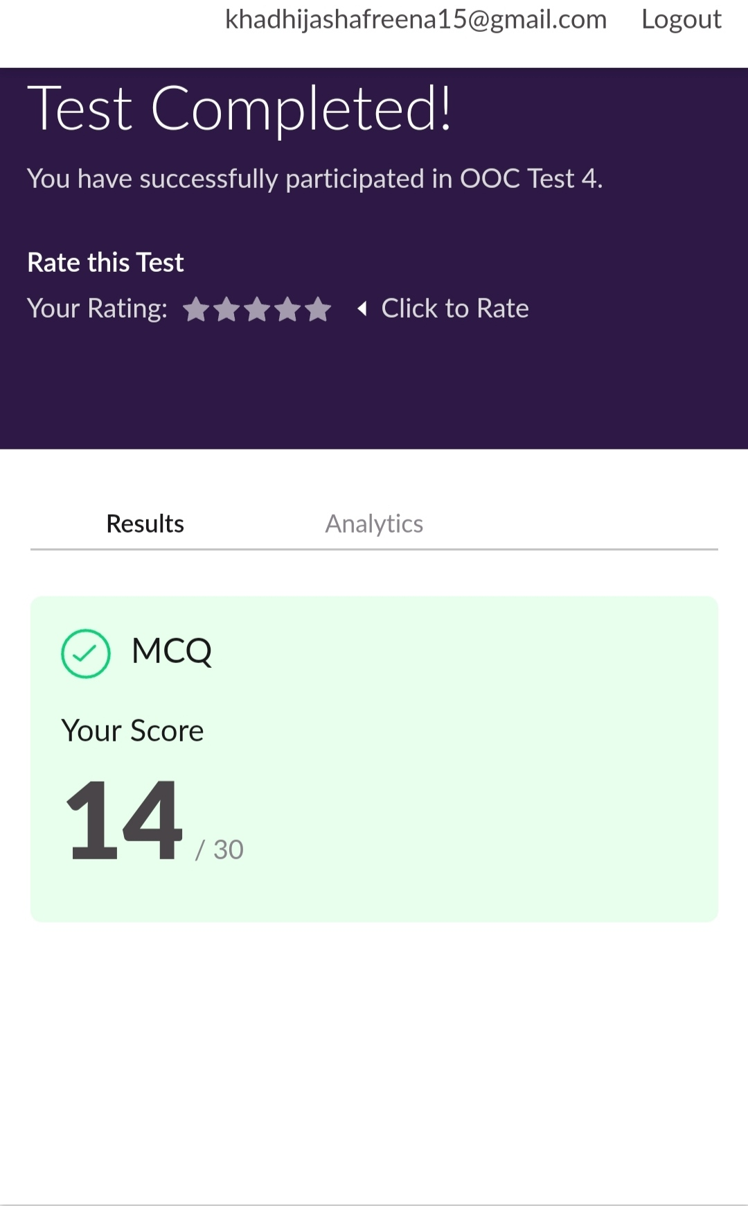

**CERTIFICATION COURSE SUMMARY**:

Today I continued certificate course on '**CLOUD FOUNDATION**', through **GREAT** **LEARNING**.The course was scheduled for 6 hrs .I completed 5 modules .I attempted quiz ,which gave me a clear veiw about the topics that were thought and discussed.It consists of 10 modules which also include assessments.

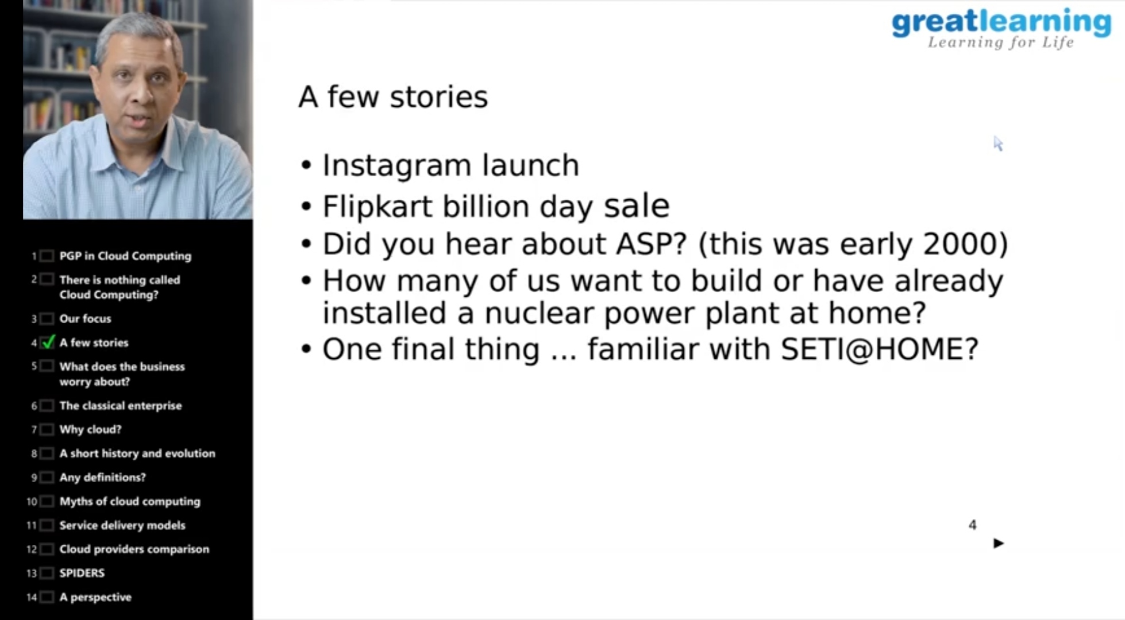

**CODING CHALLENGES:**

Today I solved 2 coding challenge,

**PROGRAM STATEMENT 1:**

1. **Java Program to find the longest repeating sequence in a string.**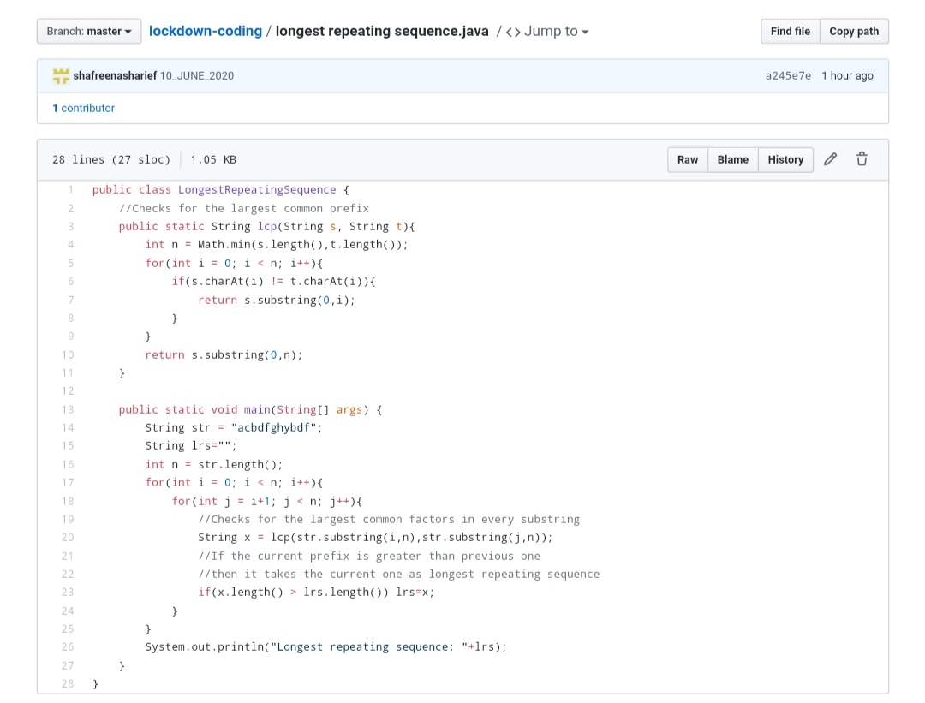

**PROGRAM STATEMENT 2 :**

**Given a matrix, the task is to print the boundary elements of the matrix and display their sum.**

**Sample Output 1:**

Enter M (Rows) and N (Columns): 3, 3

Enter the Elements: 1 2 3 4 5 6 7 8 9

OUTPUT:

The Input Matrix is:

1 2 3

4 5 6

7 8 9

The Boundary Elements are: 1 2 3 4 6 7 8 9

The Sum of Boundary elements of the Matrix is: 40

**Sample Output 2**:

Enter M (Rows) and N (Columns): 4, 5

Enter the Elements: 1 2 3 4 5 6 7 8 9 10 11 12 13 14 15 16 17 18 19 20

OUTPUT:

The Input Matrix is:

1 2 3 4

5 6 7 8

9 10 11 12

13 14 15 16

17 18 19 20

The Boundary Elements are: 1 2 3 4 5 8 9 12 13 16 17 18 19 20

The Sum of 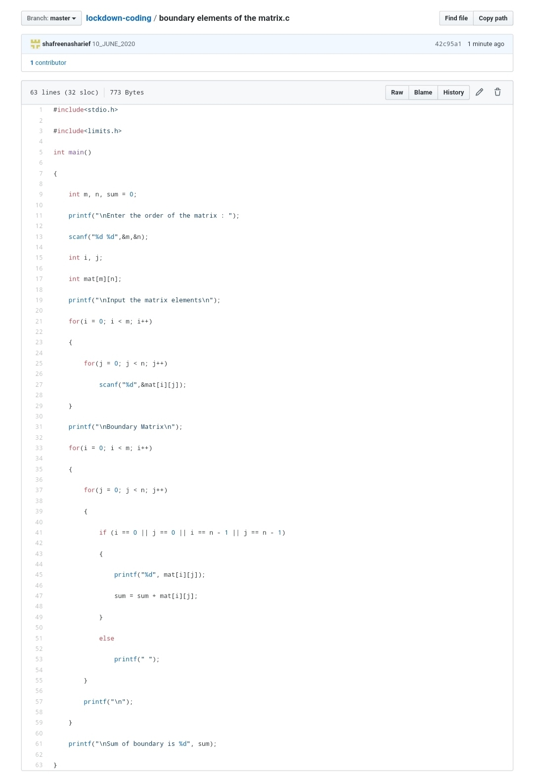Boundary elements of the Matrix is: 147

SOLUTION : I have uploaded the solution of the above 3 coding problems in my GitHub repository.

http://shafreenasharief / lockdown-coding

http://shafreenasharief / locked-down--certification-course

http://shafreenasharief / Daily\_Report